Antarctic icefish
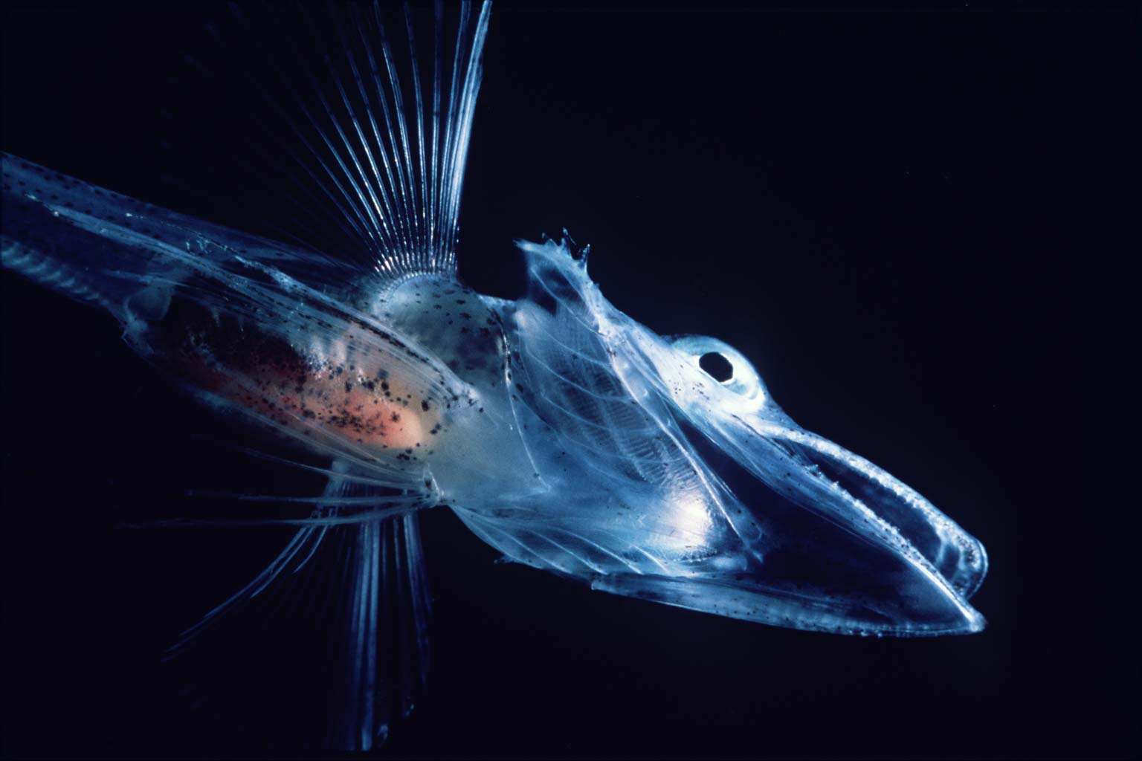
Kills, U, 2005, Icefish, https://commons.wikimedia.org/wiki/File:Icefishuk.jpg
CC BY-SA 3.0 creativecommons.org/licenses/by-sa/3.0/
The Antarctic icefish was discovered in the 1920s. It was named the ‘white crocodile fish’ by the biologist who discovered it, Ditlef Rustad. It can be found deep in the Southern Ocean to depths of over 700 metres where the temperature of the water ranges from below zero to about 1.5 °C.
The icefish can grow to a length of about 50 centimetres. It is cold blooded; however, it has no red blood cells and does not carry oxygen using haemoglobin in its blood like other vertebrates. The lack of haemoglobin and red blood cells makes the blood of the icefish colourless.
They manage this lack of ability to carry oxygen in the blood by having significantly larger hearts to pump the blood through the body and having much denser blood vessels to carry the blood than other fish. They are also able to absorb needed oxygen through their very thin skin. Antarctic icefish are also able to survive in the icy waters by having antifreeze proteins in their blood that prevent it from freezing.
Icefish have large eyes, a large mouth and many small teeth that it uses to grasp prey. They eat smaller fish and krill.
A major concern for the continued existence of the Antarctic icefish is the increasing temperatures of the Southern Ocean as they can only survive in an extreme cold environment.
References
Website — Cold-blooded and clear-blooded (American Museum of Natural History) http://www.amnh.org/explore/news-blogs/on-exhibit-posts/cold-blooded-and-clear-blooded
Website — How the Antarctic icefish lost its red blood cells but survived anyway (Scientific American) http://blogs.scientificamerican.com/brainwaves/how-the-antarctic-icefish-lost-its-red-blood-cells-but-survived-anyway/
Website — Blackfin icefish fact file (Wildscreen Arkive) www.arkive.org/blackfin-icefish/chaenocephalus-aceratus/image-G125826.html

